

SUMMER EXAMINATIONS 2013

Wednesday, 15th May 2013, 14.30 p.m. – 16.30 p.m.
KSDEM_8_Y2

Courses: Bachelor of Science (Hons) in Software Development

Year: Two

Subject: Software Development

Time Allowed: 2 Hours

Instructions: 1. Attempt any THREE (3) of the following FIVE (5)
questions.

- Questions do not carry equal marks

- Start each question on a new page.

- Write the question number at the top of each page.

- Circle the numbers of the questions you answer at the front of your answer book.

Additional Attachments or Exam Material to accompany this paper:

A. None

Internal Examiner(s) External Examiner(s)
Mr. Brendan Watson Mr. Brian Gillespie

Question 1
Read the following information and answer the questions below:

In a travel agency customers book holidays in apartment complexes. The apartment complexes consists of many apartments. Company representatives look after the customers and organise activities for them. The details stored on customers are name, address and the details stored on holidays are start date, end date, cost. The details stored on apartment complexes are address, description and the details stored on apartments are room number and capacity. The details stored on company representatives are name, salary and the details stored on activities are description, start date and duration.

- Draw the UML class diagram which models the information given above and specify name and multiplicity of each association and specify suitable types for all the attributes. Explain what the role of an association means and add roles to each of the associations in your class diagram (14 marks)

- On your UML class diagram specify that all the attributes of the customer class are private. Provide suitable assessor methods for all the attributes of the customer class (get and set methods) and specify the signature of each of the assessor methods you added.
(4 marks)

- Explain any two property strings which may be used in specifying attributes. On your UML class diagram specify the following and use suitable property strings:
- The capacity attribute of the apartment class may not be changed after the object is initialized
- Add an attribute called review of type string to the apartment complex class. Specify that the review attribute has a multiplicity of many and once a review is added it cannot be changed or deleted.
(8 marks)

- Explain interface methods. On your UML class diagram add to the company representative class, an internal method called validateSalary which has one argument for the new salary and returns a boolean value and add an interface method called alterSalary which has one argument for the new salary.
(8 marks)

(Total 34 Marks)

Question 2
- Explain actor generalisation. Use actor generalisation to simplify the use case diagram shown in figure 1 (sketch simplified use case diagram in your answer book).
(7 marks)

- Document the following use case which you participate in.
- Get cash from ATM.

Document your use case using the following headings: Use Case Name, Participating Actor, Entry Conditions, Flow of Events, and Exit Conditions. Draw the use case diagram showing the above use case.
(10 marks)

- Explain how a use case model caters for exceptional cases. Update the use case diagram you developed in answering Question 2 b) to show two exceptional cases, which could occur when a person gets cash from an ATM. Document the two exceptional cases using the following headings: Use Case Name, Participating Actor, Entry Conditions, Flow of Events, and Exit Conditions.
(11 marks)

- Document a realistic scenario for the use case you developed in answering question 2b) using the following headings: Scenario name, Participating actor instance, Entry conditions, Flow of events and Exit conditions.
(5 marks)

(Total 33 Marks)

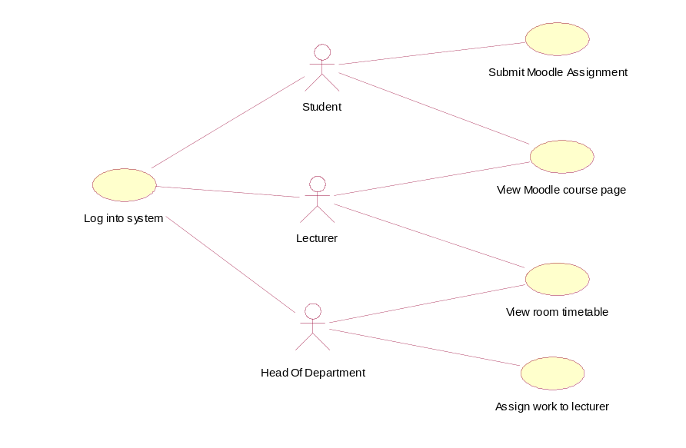

Figure 1

Question 3
- Explain what is meant by saying that inheritance is a fundamental concept in human reasoning. Suppose you were working with a problem statement and had successfully identified a few classes, explain how you would go about structuring an inheritance hierarchy in your class diagram. (10 marks)
- Sketch Figure 1 in your answer book and do the following:

(15 marks)
- Label the base class and label all of the subclasses and leaf classes.
- Add a subclass called MonsterEater. Objects of this class are like PieEaters but in addition the MonsterEater has an attribute called numPieEatersEaten of type integer and a method eatPieEater with signature of one argument named aGrid which is of type Grid
- Add a subclass called MagicPie. Objects of this class are like Pies but in addition the MagicPies have an attribute called visible of type boolean and methods appear and disappear both with signature of no arguments and return nothing.
- Add a suitable association so that just MonsterEaters may eat MagicPies.
- Override the display method in all the concrete classes in your inheritance hierarchy.
- List all the features of the MonsterEater and MagicPie classes. Does the UML diagram that you produced in answering Question 3b) allow MonsterEaters to eat Pies. Explain your answer.
. (8 marks)

(Total 33 Marks)
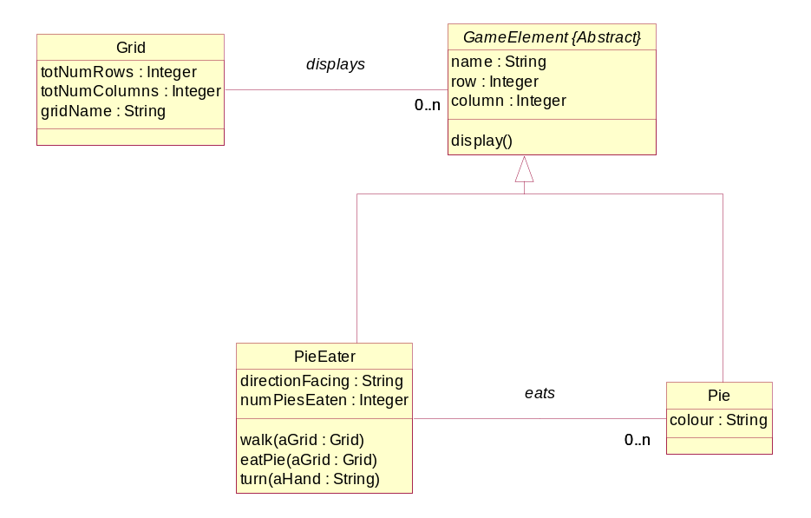
Figure 1

Question 4
- Explain unit testing. How does functional and structural testing apply to unit testing?
(6 marks)

- Develop a control flowgraph for the pseudo code sample below and determine the complexity. What would you conclude about a piece of code that has been tested so that TER0 = 1 and TER1 = 0.90? Has complete coverage been achieved and would you recommend further testing?
(12 marks)

- Develop a branch and block table for the Pseudo code sample below.
(15 marks)
(Total 33 Marks)

// Below is Psuedo code for spinAndEatPie method.

//Line Reference Nos
spinAndEatPie (aGrid : Grid) : integer // 1
{ // 2
8 timesOfRepeat // 3
{ // 4
turn(right) // 5
If ( aGrid PieInSight(this) = true) // 6
{ // 7
eatPie(aGrid) // 8
4 timesOfRepeat // 9
{ // 10
turn(right) // 11
} // 12
walk(aGrid) // 13
4 timesOfRepeat // 14
{ // 15
turn(right) // 16
} // 17
} // 18
} // 19
return pieCount // 20
} // 21

Pseudo Code Sample

Question 5
- In relation to object orientation explain abstraction. Explain why it is useful. When modelling a system, why is it normally viewed from more than one perspective?
(12 marks)

- Describe any four of the five interlocking views that can be used to describe the architecture of a software system. Why do you think there are UML diagrams which capture both the static and dynamic aspects of each view?
(13 marks)
- Are each of the five views you described in answering question 5b) created in one go? Explain your answer.
(8 marks)
(Total 33 Marks)

